TASK 1:
UML DIAGRAM:
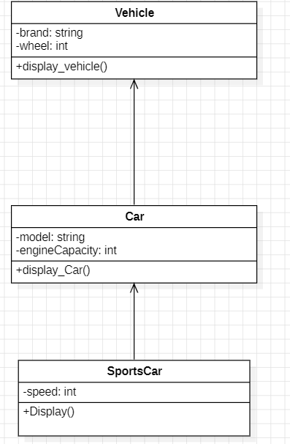

TASK NO 2
UML DIAGRAM:
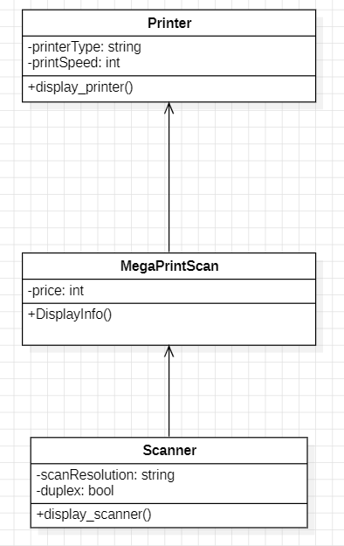

TASK NO 3
UML DIAGRAM
